**Database Design Coursework**

Student Name: Dominykas Milkintas

Student ID: 240012813

Student Number: 240012813

**Scenario Topic Name** Gym management system

**Scenario:** In this gym management system, a new member registers using their email and other personal information at one of the chains. The system automatically assigns the member with a membership plan with benefits tailored to what type of membership they applied for. Members also have the option to apply to become a trainer. Trainers can be supervised by other trainers. Members get access to fitness classes which have difficulty levels. Attendance is recorded in the database and a trainer guides the member through the class. Members gain a code which allows them to enter and leave the gym and they are notified about the renewal and upcoming classes.

**Example queries**

How many members are currently registered at each gym location?

Which trainers have the most years of experience?

Who has the highest attendance count in fitness classes among all members?

Which fitness class has the least capacity?

Which fitness plan is the most popular?

**Entity Relationship Model**

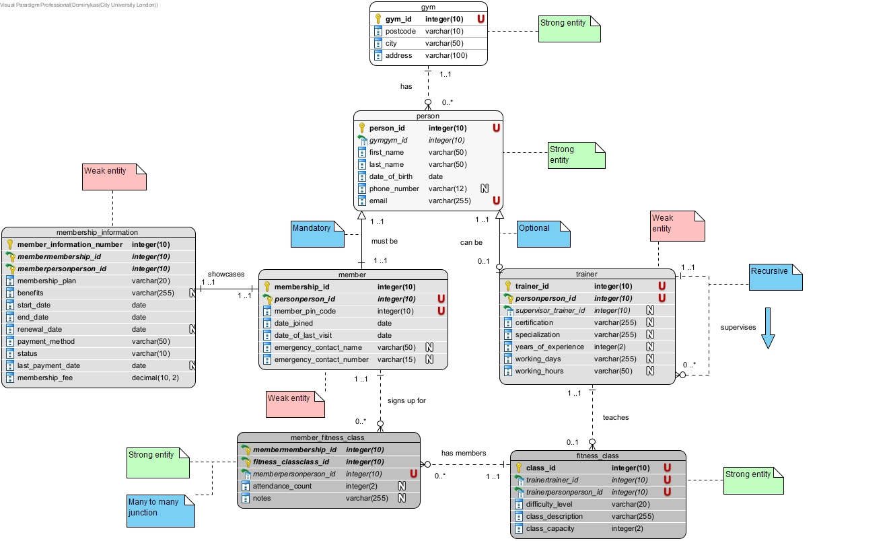

**Relational Model Tables**

* Copy and paste the table below for as many relational tables as you need
* Replace the placeholder names (table-name1, attribute-name5 etc) with the table and attribute names you derived from your ER model
* List primary key attributes first
* Add new rows to the tables (in the correct place) as needed
* Delete any unnecessary rows (attribute rows and foreign key rows if not used)
* Primary keys are to be specified in the format PRIMARY KEY (attribute-name1, attribute-name2, etc)
* Foreign keys are to be specified in the format ‘FOREIGN KEY (attribute-name) REFERENCES table-name (attribute-name)

|  |  |
| --- | --- |
| **Relational table specification** | **Marker’s corrections (Do not write in this column)** |
| **Table name:** gym |  |
| **Attributes** |  |
| gym_id |  |
| postcode |  |
| city |  |
| address |  |
| **PRIMARY KEY** (gym_id) |  |

|  |  |
| --- | --- |
| **Relational table specification** | **Marker’s corrections (Do not write in this column)** |
| **Table name:** person |  |
| **Attributes** |  |
| person_id |  |
| gymgym_id |  |
| first_name |  |
| last_name |  |
| date_of_birth |  |
| phone_number |  |
| email |  |
| **PRIMARY KEY** (person_id) |  |
| **FOREIGN KEY** (gymgym_id) REFERENCES gym (gym_id) |  |

|  |  |
| --- | --- |
| **Relational table specification** | **Marker’s corrections (Do not write in this column)** |
| **Table name:** member |  |
| **Attributes** |  |
| membership_id |  |
| personperson_id |  |
| member_pin_code |  |
| date_joined |  |
| date_of_last_visit |  |
| emergency_contact_name |  |
| emergency_contact_number |  |
| **PRIMARY KEY** (membership_id, personperson_id) |  |
| **FOREIGN KEY** (personperson_id) REFERENCES person (person_id) |  |

|  |  |
| --- | --- |
| **Relational table specification** | **Marker’s corrections (Do not write in this column)** |
| **Table name:** membership_information |  |
| **Attributes** |  |
| member_information_number |  |
| membermembership_id |  |
| memberpersonperson_id |  |
| membership_plan |  |
| benefits |  |
| start_date |  |
| end_date |  |
| renewal_date |  |
| payment_method |  |
| status |  |
| last_payment_date |  |
| membership_fee |  |
| **PRIMARY KEY** (member_information_number, membermembership_id, memberpersonperson_id) |  |
| **FOREIGN KEY** (membermembership_id) REFERENCES member (membership_id) |  |
| **FOREIGN KEY** (memberpersonperson_id) REFERENCES person (person_id) |  |

|  |  |
| --- | --- |
| **Relational table specification** | **Marker’s corrections (Do not write in this column)** |
| **Table name:** trainer |  |
| **Attributes** |  |
| trainer_id |  |
| personperson_id |  |
| supervisor_trainer_id |  |
| certification |  |
| specialization |  |
| years_of_experience |  |
| working_days |  |
| working_hours |  |
| **PRIMARY KEY** (trainer_id, personperson_id) |  |
| **FOREIGN KEY** (personperson_id) REFERENCES person (person_id) |  |
| **FOREIGN KEY** (supervisor_trainer_id) REFERENCES trainer (supervisor_trainer_id) |  |

|  |  |
| --- | --- |
| **Relational table specification** | **Marker’s corrections (Do not write in this column)** |
| **Table name:** fitness_class |  |
| **Attributes** |  |
| class_id |  |
| trainertrainer_id |  |
| trainerpersonperson_id |  |
| difficulty_level |  |
| class_description |  |
| class_capacity |  |
| **PRIMARY KEY** (class_id) |  |
| **FOREIGN KEY** (trainertrainer_id) REFERENCES trainer (trainer_id) |  |
| **FOREIGN KEY** (trainerpersonperson_id) REFERENCES person (person_id) |  |

|  |  |
| --- | --- |
| **Relational table specification** | **Marker’s corrections (Do not write in this column)** |
| **Table name:** member_fitness_class |  |
| **Attributes** |  |
| membermembership_id |  |
| fitness_classclass_id |  |
| memberpersonperson_id |  |
| attendance_count |  |
| notes |  |
| **PRIMARY KEY** (membermembership_id, fitness_classclass_id) |  |
| **FOREIGN KEY** (membermembership_id) REFERENCES member (membership_id) |  |
| **FOREIGN KEY** (fitness_classclass_id) REFERENCES fitness_class (class_id) |  |

**Marker’s Comments** (Do not write in this section)

**Coursework Mark** (100 marks available):